**STRUCTURE AND FUNCTIONS**

**Refer the code in “student.c”. Implement the following requirements.**

**a. Change the name member to char * datatype**

**b. Add 2 functions below to read and store name and percentage scores from user in student record.**

**//pass name address as parameter and read and update name field Return updated name**

**char *read_update_name(char *name);**

**//pass address of percentage as parameter, read and update percentage field of student record. Also return updated percentage**

**int read_update_percentage(int *percent);**

**c. Check for memory leaks**

**d. Specify atleast 5 dataset used for testing**

**Check for memory leak.**

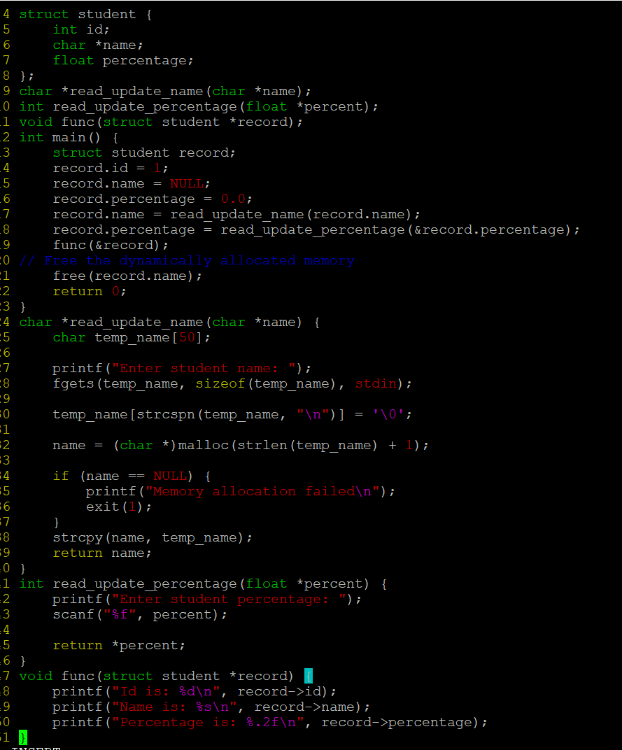

**OUTPUT:**

